Names, job titles and email addresses:
- Joseph Elliott, Senior Analyst, joseph.elliott@jrf.org.uk
- Rachelle Earwaker, Senior Economist, Rachelle.earwaker@jrf.org.uk
Institutional affiliation: Joseph Rowntree Foundation

Title: Renters on low incomes face a policy black hole: homes for social rent are the answer

Abstract: This briefing analyses the large number of households on low incomes paying rents they cannot afford in the private rented sector. It provides new analysis on the depth and geographical spread of this problem and examines the Government’s policy response, which is not currently succeeding either in making renting more affordable or in making homeownership accessible to this group.

It shows why significantly increasing the supply of homes for social rent is the solution – 90,000 a year for the next 15 years – and sets out the level of investment the Government should commit to at this autumn’s Comprehensive Spending Review to deliver them.

Word count: 7,000 (excl. references and methodology note – see attached)

Renters on low incomes face a policy black hole: homes for social rent are the answer
This briefing analyses the large number of households on low incomes paying rents they cannot afford in the private rented sector. It provides new analysis on the depth and geographical spread of this problem and examines the Government’s policy response, which is not currently succeeding either in making renting more affordable or in making homeownership accessible to this group.

It shows why significantly increasing the supply of homes for social rent is the solution – 90,000 a year for the next 15 years – and sets out the level of investment the Government should commit to at this autumn’s Comprehensive Spending Review to deliver them.

Executive Summary
It is not right that the high cost of private renting is leaving almost one million families paying rents they cannot afford [see definition on page 4]. This is leaving nine in ten of these families in poverty, with some family budgets more than £100 a week below the poverty line as a result. The Government’s current plans don’t come close to addressing the problem. There is an urgent need to ease the pressure on these families to reduce poverty, improve living standards and allow more people to save for their family’s future.
Work is not a guaranteed route to being able to afford your rent, and this affordability crisis is hitting working families hard. 748,000 families who cannot afford their rent have one or more adult in work, two-thirds of whom work full-time.
Sky-high rents in London can be devastating but this problem affects all of England. Private renters are more likely to be on low incomes in the North (55%) and Midlands (48%) and, despite rents being cheaper on average, around 418,000 renters in these areas are paying rents they cannot afford. The Government will not fulfil its promise to improve the lives of people on the lowest incomes and ‘level up’ the country without a long-term plan to tackle this problem.
The majority of the Government’s policy responses – Housing Benefit; the affordable rent scheme which lets properties at up to 80% of market rates; and homeownership products like Help to Buy, First Homes and the Mortgage Guarantee Scheme – are either not working for this group, or only working for a small proportion of them.
The Government’s ‘affordable rent’ scheme can ease pressure on some families on low incomes; 25% of families currently paying rents they can’t afford would find this tenure affordable. However, this leaves three-quarters of this group unable to afford ‘affordable’ rents.
The homeownership products that form the cornerstone of Government housing policy are out of reach for the majority of this group: homes bought through Help to Buy would only be affordable to 2% of low-income private renters, and most of the current products, including the mortgage guarantee schemes and First Homes, are unaffordable to nine in ten low-income renting families. These products work for people already on the cusp of homeownership, but there is a policy black hole for low-income renters.
Housing benefit plays a vital role in helping low-income households with their housing costs, but years of cuts and freezes have undermined its effectiveness. Around half of the 956,000 families paying rent they can't afford receive Housing Benefit but are still struggling. By itself, subsidising high private rents through the benefits system is not a sustainable solution to this problem. Housing Benefit costs the state around £30 billion a year, a large proportion of which goes to private landlords.
The Government’s current ambitions to deliver 6,000 homes for social rent a year over five years through the Affordable Homes Programme is nowhere near ambitious enough. This number won’t even meet the needs of people currently on waiting lists; the people identified in this analysis do not stand to benefit from current plans.
Our recommendations:
The Government must step up its housebuilding efforts to reach its target of 300,000 homes a year and must ensure that 30% of these are homes for social rent. In the near term, this would meet the needs of the 1.1 million households on the social housing waiting list, as well as people experiencing homelessness, and support the Government’s own aim to reduce homelessness and end rough sleeping this parliamentary term. Over the long term, it could lift 600,000 people who are renting privately out of poverty; provide more than half a million households with a home they can afford; and ease the pressures of high rents for the majority of the other half a million households paying rents they cannot afford, many of whom will be on social housing waiting lists. It will reduce the Housing Benefit bill and support the delivery of better quality, more energy-efficient homes that better meet the needs of families on low incomes. It would also increase access to the most successful affordable home-ownership scheme available to low-income renters England: Right to Buy.
With much greater scale of ambition, we can begin to deliver homes people can genuinely afford; lift people out of poverty; and strengthen the proven pathway to affordable homeownership through social housing, as well as supporting our economic recovery.

To do this, the Government must commit to 30% of its annual target of 300,000 homes being for social rent that are affordable to people on the lowest incomes.

Delivering this will require an increase in grant funding on top of what has already been committed in the current Affordable Homes Programme. An ongoing annual capital investment of an extra £11 to £14 billion in the Affordable Homes Programme would deliver 90,000 homes for social rent a year – funding that the Government should commit to at this autumn’s Comprehensive Spending Review. This spending is needed over 15 years to meet the country’s demand, following a period of low investment, but now is the time to commit to that spending as borrowing costs remain historically low. The precise figure will depend on whether the planning system can deliver an increase in the supply of homes for social rent through developer contributions.

An increase on this scale will not be accomplished overnight – given lead-in times for housing developments – so the Government should use the spending review to set a clear intent in relation to both the target for new social homes and the level of public investment it will build up to over the coming years to get there (as the public finances continue to be repaired post-Covid).

This briefing primarily considers housing affordability for low-income private renters – those in the bottom 40% of incomes.

For the purpose of our briefing, we consider the 2.68 million private-renting households in middle- to high-incomes (top 60% of incomes) to have affordable rents. For these renters, the rents they pay are more likely to reflect choice than necessity and are less likely to result in financial strain for the household. However, we acknowledge many in this group may still feel the strain of high housing costs.

See methodology note for further detail and worked examples.
*Rents disproportionately high relative to incomes means gross rents (before Housing Benefit) are more than 30% of net incomes (after Housing Benefit).

Unaffordability pressures: private renters in the bottom 40% of incomes who spend less than 30% of their income on rent (after Housing Benefit), but for whom rents are disproportionately high relative to incomes*, while incomes are so low that many will find it difficult to cover the rest of their rent; the vast majority of this group are in poverty after housing costs.

341,000 households, all of whom receive some Housing Benefit

624,000 households, including 185,000 who receive some Housing Benefit

Unaffordable rents: private renters who are in the bottom 40% of incomes and who spend more than 30% of their income on rents (after Housing Benefit), a widely used definition of housing affordability.

Our definitions of affordability
Throughout this briefing we refer to households who are paying rents they cannot afford, which, unless otherwise stated, refers to renters who fall into either of the following two groups:

Affordable: private renters in the bottom 40% of incomes whose rents are covered by Housing Benefit. However, this group is particularly vulnerable to changes in adequacy and coverage of social security benefits.

274,000 households, all have rents covered by Housing Benefit

Affordable: private renters in the bottom 40% of incomes whose rents are less than 30% of incomes, and rents aren’t disproportionately high relative to incomes*. However, many in this group (just under half) are still in poverty after housing costs.

525,000 households, including 218,000 who receive some Housing Benefit
We define rents as being affordable for the following groups:
Source: JRF analysis using Family Resources Survey 2019/20 and IPPR Tax and Benefit model. Incomes and prices at April 2021.

The high cost of private renting leaves almost one million low-income private renting households paying rents they can’t afford
It is not right that so many low-income private renters are paying rents they can’t afford. Our new analysis shows that out of 1.8 million low-income private renting households¹, almost a million (965,000, 55%) are in this boat. As Graph 1 shows, 36% (624,000) are facing unaffordable rents which eat up more than 30% of their incomes, even after Housing Benefit is factored in. A further 19% (341,000) face unaffordability pressures that housing benefits only go some way to easing, because their incomes are so low that many will still be left struggling to make ends meet after paying rent. That’s too many low-income private renting households paying rents they can’t afford.

A significant group of low-income private renters face even deeper housing affordability problems. 387,000 (22%) households are spending more than 40% of their disposable income on rents. This means that these households are facing ‘housing cost overburden’, the particularly acute experience of housing unaffordability.

Graph 1: 965,000 (55%) low-income private renting households are paying rents they cannot afford
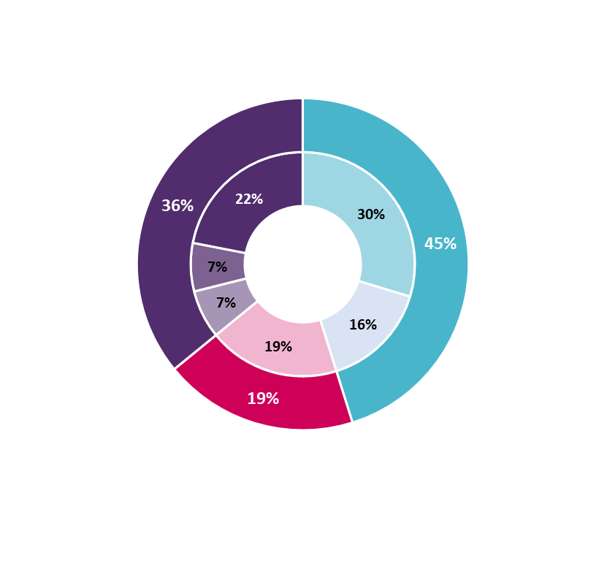
Unaffordable: 624,000
Affordable:
798,000
Unaffordability pressures: 341,000
Affordability of current rents paid by low-income private renters
Total households paying rents they cannot afford: 965,000
Source: JRF analysis using Family Resources Survey 2019/20 and IPPR Tax and Benefit model. Incomes and prices at April 2021.

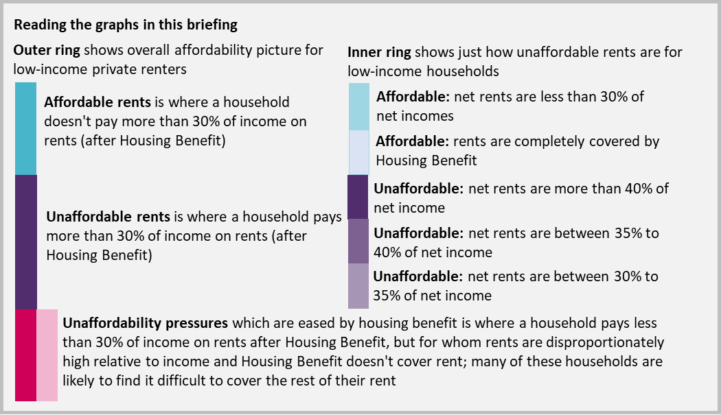

For this analysis, we consider the 16% of low-income private renting households who have all rent covered by Housing Benefit to have affordable housing. However, this group is particularly vulnerable to changes in the coverage or adequacy of social security which could result in their housing costs becoming unaffordable. This in turn could force them to use disability, out-of-work or other benefits they receive to help meet other essential costs in order to cover their housing costs.

Unaffordable housing costs are a key driver of poverty, restricting families’ ability to buy essentials

Low-income private renters with unaffordable rents are living below the poverty line
Unaffordable rents can have significant consequences for families’ living standards and are a key driver of poverty. The vast majority (86%, 826,000) of the households we identify as having unaffordable rents or unaffordability pressures are in after housing costs (AHC) poverty. Box 1 below illustrates the impact on typical low-income families of paying rents they cannot afford; the average couple with children is left with £306 a week to live on, £102 below the poverty line, while the average single adult living alone is left with £104 a week to live on and £65 below the poverty line. Paying such a large proportion of already low incomes on rents forces impossible trade-offs between turning on the heating and putting food into the fridge.

Box 1: Impact of unaffordable private rents on different households across England
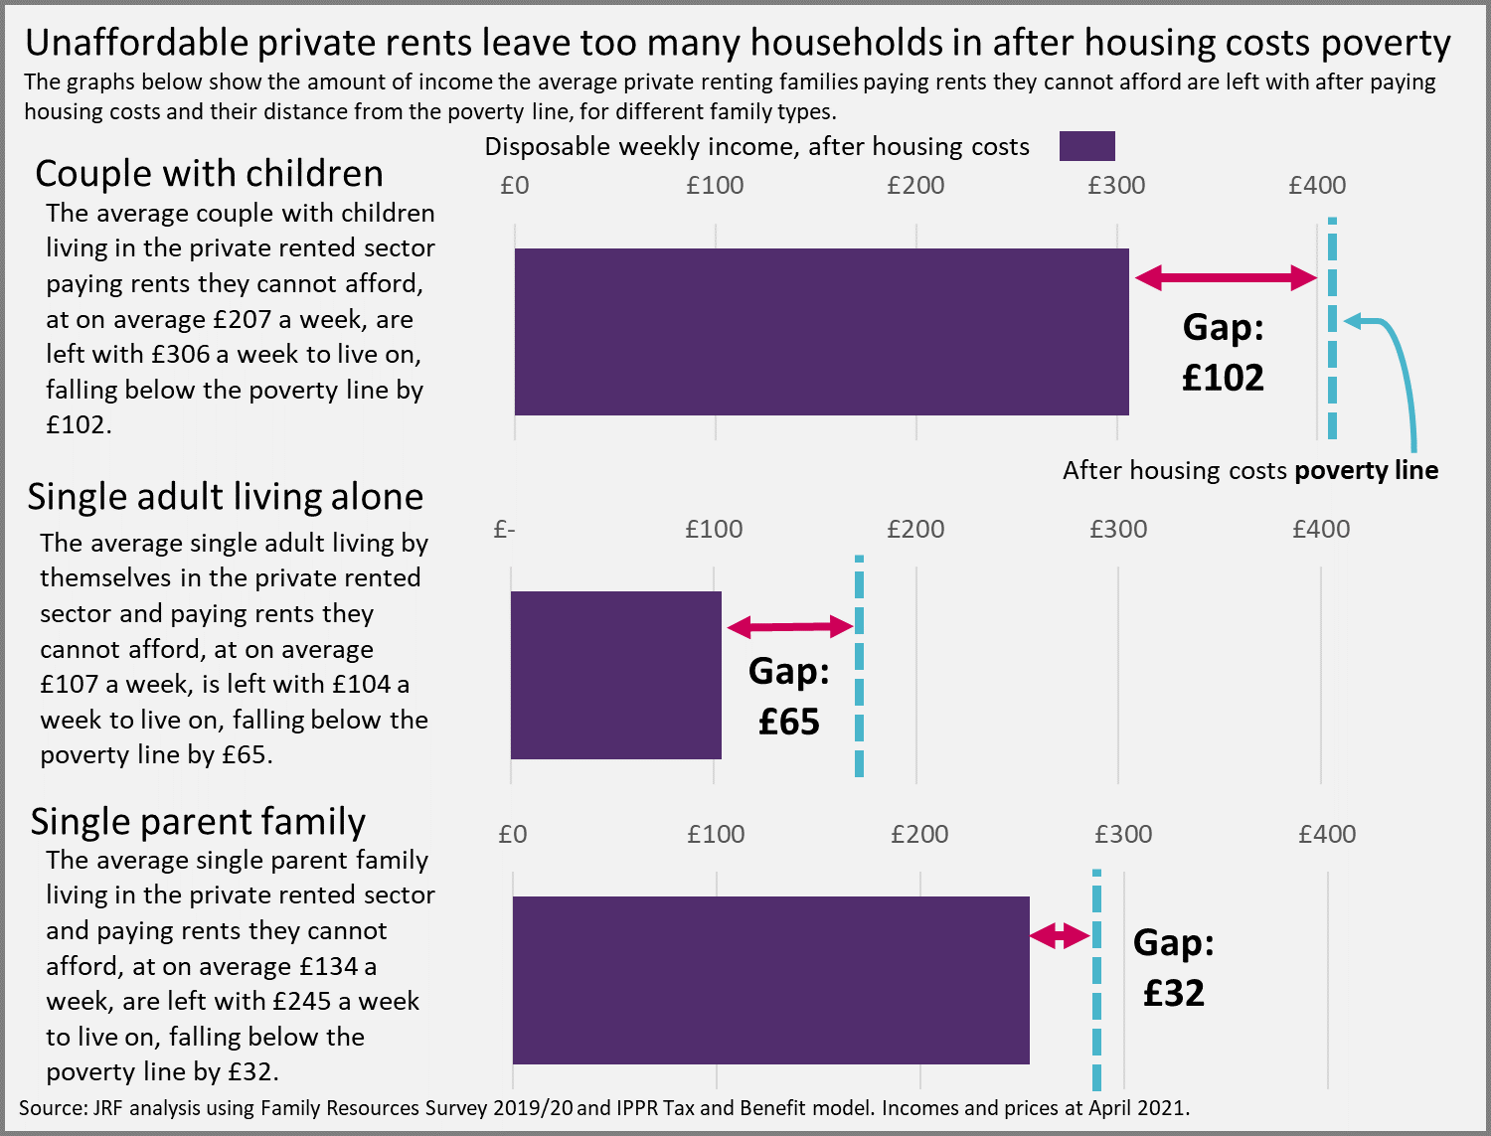

Housing Benefit doesn’t go far enough to make the private rental sector affordable. Our modelling finds that of the estimated 1 million low-income private renting households in receipt of Housing Benefit, around half (51%) still find rents unaffordable (18%) or face unaffordability pressures (33%) as they’re left with too little income after making up the difference between rents and Housing Benefit.

Renting is particularly unaffordable for in-work renters and BAME renters, while many families with children are faced with impossible budgeting trade-offs

Four in five low-income, private renting households who are in work find too much of their earnings are eaten up by high rents
Work is not a guaranteed route to being able to afford your rent. Four in five (748,000) households unable to afford their rent have one or more adults in work, two-thirds of whom work full-time. Too many find that the high cost of private renting is eating up too much of their earnings, leaving them struggling to budget what they have left for other essentials. It’s clear the private rented sector isn’t working for low-income renters if even people in full-time employment are struggling to pay rents and are left in poverty after housing costs.

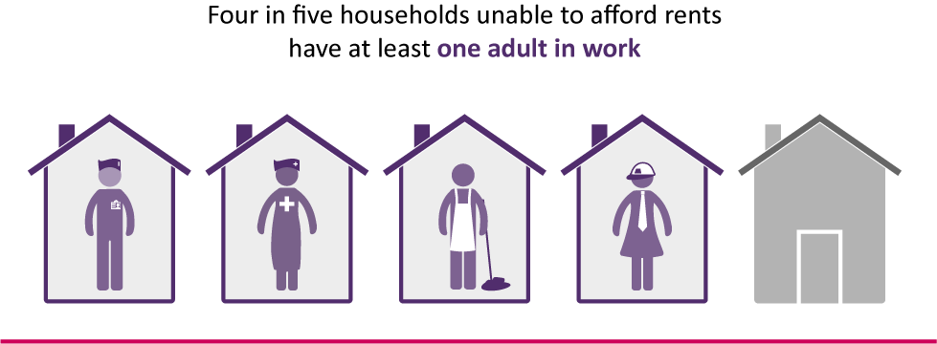

Many low-income privately renting households where nobody is in formal employment (for example. retired, have caring or parenting responsibilities, unable to work because of illness or disability, or looking for work) also face rental affordability pressures. A quarter find housing costs unaffordable and a further one in ten face unaffordability pressures. While many will receive support towards housing costs through Housing Benefit, it often isn’t enough and forces them to use other sources of income which are designed to meet other essential costs, such as disability or other benefits, to cover rent.

Almost half a million families with children are facing rental affordability pressures, leaving them with too little to live on
The number of families with children living in the private rented sector has tripled since the start of the century, to more than 1.5 million families and 2.7 million children. This has been driven by the huge growth in house prices relative to incomes, which leaves young families with little choice but to rent privately at high cost and prevents them from getting on the housing ladder. In previous generations many of these families would have lived in the much more affordable and secure social rented sector. But as the supply of social rent dwellings has declined, more families have been pushed into the private rented sector.

Three in ten of these private renting families with children (443,000) are paying rents they cannot afford. The consequences for these families can be severe; 90% are in after housing costs poverty, with expensive rents often forcing impossible trade-offs between putting food on the table or money on the electric.

Many single adults without children also struggle with rental unaffordability pressures. They are much more likely to be on low incomes than couples without children; 43% of privately renting single adults (535,000) are in the bottom 40% of incomes², compared with 23% of couples without children. Stumping up the rent for a one-bed flat is clearly much harder for a single adult than a couple with a combined income; over half, 304,000, low-income single adults in the private rented sector are paying rents they cannot afford.

BAME households are more likely to live in the private rented sector, to be on low incomes and to be paying rents they cannot afford
A higher proportion of Black, Asian and minority ethnicity (BAME)³ households are in the private rented sector (28%) than White households (18%). BAME households are also more likely to be on low incomes. Of the group of low-income BAME private renters, 65% (252,000 households) are paying rents they cannot afford, compared with 52% of low-income White households. There is a geographic component to this – BAME households are more likely to live in areas with higher rents such as London – but it is also driven by income inequalities which BAME people face in the labour market (Barry, 2021) and features of the social security system, such as the benefit cap, which disproportionately impact BAME households.

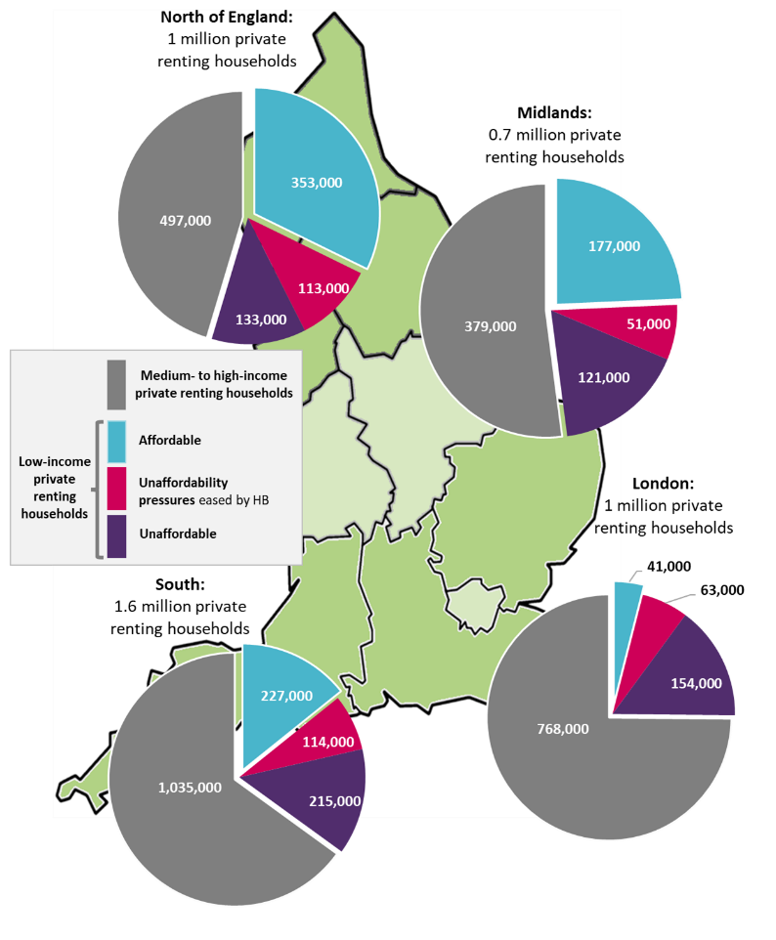
Private rental unaffordability isn’t just a problem in London and the South: more than four in ten private renters with rental unaffordability problems are in the North and Midlands
Source: JRF analysis using Family Resources Survey 2019/20 and IPPR Tax and Benefit model. Incomes and prices at April 2021. Assumptions detailed in methodology note.
Graph 2: Many low-income private renting households in the North and Midlands are paying rents they cannot afford
Many private renters in the North and Midlands, where private rents are on average much cheaper than in London and in the South, still face substantial unaffordability pressures. While a higher proportion of low-income renters in the North and Midlands find their rents affordable compared with those in London and the South, a much higher proportion of private renting households in the North (55%) and Midlands (48%) are on low incomes compared with the South (35%) and London (25%). Of these low-income private renting households in the North and Midlands, 418,000 are paying rents they cannot afford, making up more than four in ten of all households paying rents they cannot afford.

The sky-high rents in London, particularly when combined with the effects of the benefit cap in limiting support for families, can be devastating for low-income households. Rents are only affordable for fewer than one in five (16%) low-income private renting households in London, while almost half (45%), 117,000 households, are spending more than 40% of their incomes on rents – a particularly acute experience of housing unaffordability. In the South, where rents are also comparatively high, 329,000 households are paying rents they cannot afford.

It is not right that private renters on low incomes across England are being pushed into poverty and hardship by high housing costs and inadequate support from the benefits system.

Current Government policies to make renting more affordable are not working for people on low incomes

Our analysis has shown that far too many low-income households face unaffordable housing costs in the private renting sector, putting a strain on their finances and severely affecting their living standards. This is driven by our current heavy reliance on the private rented sector, which has doubled in size in the last 20 years.
While the benefits system anchors some families against being swept into poverty, for too many the support it provides is insufficient. Housing Benefit plays a vital role in helping low-income households with their housing costs, but years of cuts and freezes have eroded its value. Subsidising high private rents through the benefits system is also not a sustainable solution to the unaffordability crisis facing private renters. Housing Benefit costs the state around £30 billion a year, a large proportion of which goes to private landlords.

The Government has taken some steps to ease unaffordability pressures by introducing the affordable rent scheme, where rents are set at up to 80% of market rents, rather than tied to incomes. But as our new modelling shows, this leaves ‘affordable rents’ out of reach of many. Instead, what we need is more investment in homes for social rent.

‘Affordable rents’ won’t work for many: three-quarters of low-income renters unable to afford their current private rents would find them unaffordable
‘Affordable rent’ homes have made up around half of the homes offered through the Government’s Affordable Homes Programme (AHP). While ‘affordable rent’ dwellings are cheaper than average private renting properties, they are priced at up to 80% of market rents rather than being tied to households' incomes, and as such remain unaffordable for many.

New JRF analysis has modelled the impact of moving low-income private renters currently unable to afford their rents into ‘affordable rent’ housing and found that ‘affordable rents’ would be affordable for just a quarter (25%) of these households. The other three-quarters – 695,000 households – would find ‘affordable rents’ too expensive. It is clear that ‘affordable rent’ – the Government’s preferred ‘low-cost’ rental product – isn't the solution for the majority of low-income renters.

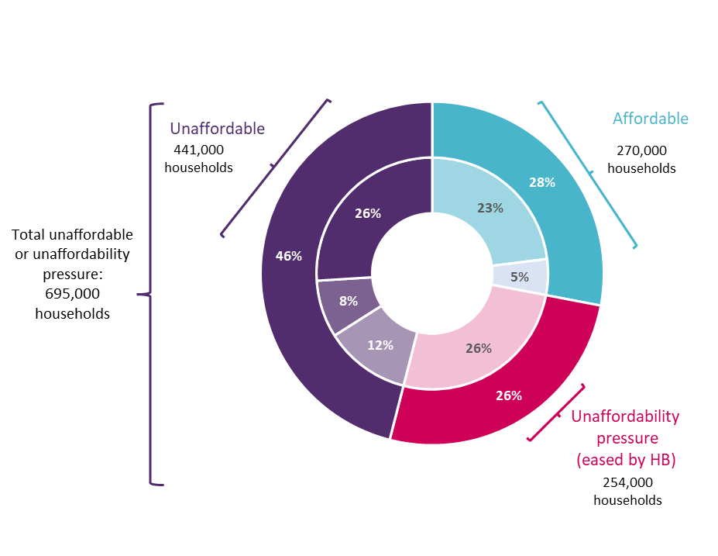
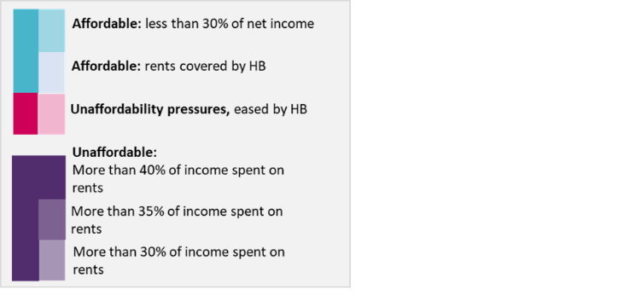
Graph 3: ‘Affordable rent’ would be unaffordable for three-quarters of the low-income private renting households currently unable to afford their private rents
Source: JRF modelling of the impact of moving low-income private renting households currently paying rents they cannot afford to an appropriately sized affordable rent home at the average price for that dwelling by region and bedroom size.
Analysis uses Family Resources Survey 2019/20 and IPPR Tax and Benefit model. Incomes and prices at April 2021. Assumptions detailed in methodology note.
Affordability of ‘affordable rents’ for low-income private renters currently paying private rents they cannot afford
.

‘Affordable rent’ homes may help some families on higher incomes access a better standard of living through cheaper housing, but they are not helping the low-income families who need genuinely affordable, cheaper rental accommodation to stay afloat and have a decent standard of living.

Homeownership schemes are not helping low-income private renting households onto the housing ladder

It is now much harder than in the past for low-income households to get onto the housing ladder
Historically, the most successful scheme for helping low-income households into homeownership has been Right to Buy. But as the supply of social rented stock has decreased – in part due to a lack of direct replacement of the homes lost through Right to Buy – low-income households who may have previously been able to access social housing and the chance to own their own home that came with it can no longer do so.

For many low-income private renting households, the combined barriers of substantial deposit requirements and expensive monthly mortgage repayments due to high house prices are insurmountable and mean homeownership isn’t a realistic option in the near term. House prices were much higher relative to incomes at almost eight times average earnings in 2020, compared with five times earnings at the start of the century (ONS, 2021). As house prices have soared since 2020, this ratio is continuing to rise.

During the pandemic, house prices have continued to rise. At some points, we have seen annual growth of over 15 per cent for most of the country outside of London. Some regions in the North have seen growth closer to 20%. Higher house prices mean larger deposits and more borrowing, but many renters simply don’t have the money available for a deposit and expensive private rents limit the ability to save. The Government’s own figures report that 60% of private renters have no savings (DLUHC, 2020), while recent analysis reports that during the pandemic low-income families were much more likely to use up rather than increase savings (Leslie and Shah, 2021). For many, homeownership is simply not a realistic prospect in the short term.

Government has sought to address these challenges by introducing a range of homeownership schemes, but these schemes will not help the vast majority of low-income private renters into ownership, leaving a policy blindspot for low-income private renters who are stuck paying rents they cannot afford.

Even with the Government’s schemes, homeownership is out of reach for the vast majority of low-income private renters
Table 1 outlines the range of homeownership support products the government currently has on offer in England.

Table 1: Homeownership support products
Homeownership product | Scheme details | Assumptions for analysis
Help to Buy Equity Loan | Government provides an equity loan enabling a first-time buyer to achieve a 95% loan in total. Enables people to buy a new home with small deposits. Price limits by region. For FTBs only. Minimum 5% deposit. | LQ house prices for new homes, lower of the house price cap by region. 5% deposit.
First Homes | Government discount of at least 30% on new homes for FTBs with regional price caps and household income caps of £250k and £80k outside London and £420k and £90k London. Minimum 5% deposit. | LQ house prices for new homes, lower of the house price cap, by region. 5% deposit.
Mortgage Guarantee Scheme | Government backed lending so that banks offer 95% mortgages, to reduce deposit requirements. | LQ house prices for all homes by region. 5% deposit.
Shared ownership | Allows households who can’t afford a full mortgage/deposit to buy a minimum of 25% share of a home and pay rent on the rest. 5% minimum deposit required for the ownership share. Household income caps of £90k in London and £80k outside London apply. | 25% ownership option for LQ house prices by region. Rent calculated based on Shared Ownership formula ((Non ownership share/100 x 3)/12).
Regular mortgage | 10% deposit on a home | Median house prices by region. 10% deposit.
Source: Own your home, all schemes (DLUHC, 2021d)
Note: Prices, interest rates and deposit requirements and data sources for each scheme and region set out in methodology note

Our new analysis shows that most of the current products offered to first time buyers would be unaffordable to at least 90% of low-income private renting families. As shown in Graph 4 below, Help to Buy, First Homes and the Mortgage Guarantee Scheme would be unaffordable for more than nine in ten low-income private renting households. Help to Buy was one of the star products of the last decade of helping people into their own homes, but reports show that these mainly helped those on the cusp of ownership. As Graph 4 illustrates, homes bought through Help to Buy would only be affordable to 2% of low-income private renters and would mean paying more than 40% of income for more than nine in ten renters. And while Shared Ownership homes can be the most affordable route to homeownership for low-income private renters, it would still be unaffordable to almost 7 in 10 (67%) households. While these schemes may benefit those already on the cusp of ownership, they will not help affordability of housing for low-income private renters.

Graph 4: Homeownership options are unaffordable for the majority of low-income private renters
Source: JRF analysis using Family Resources Survey 2019/20 and IPPR Tax and Benefit model. Incomes and prices at April 2021. Assumptions detailed in methodology note.
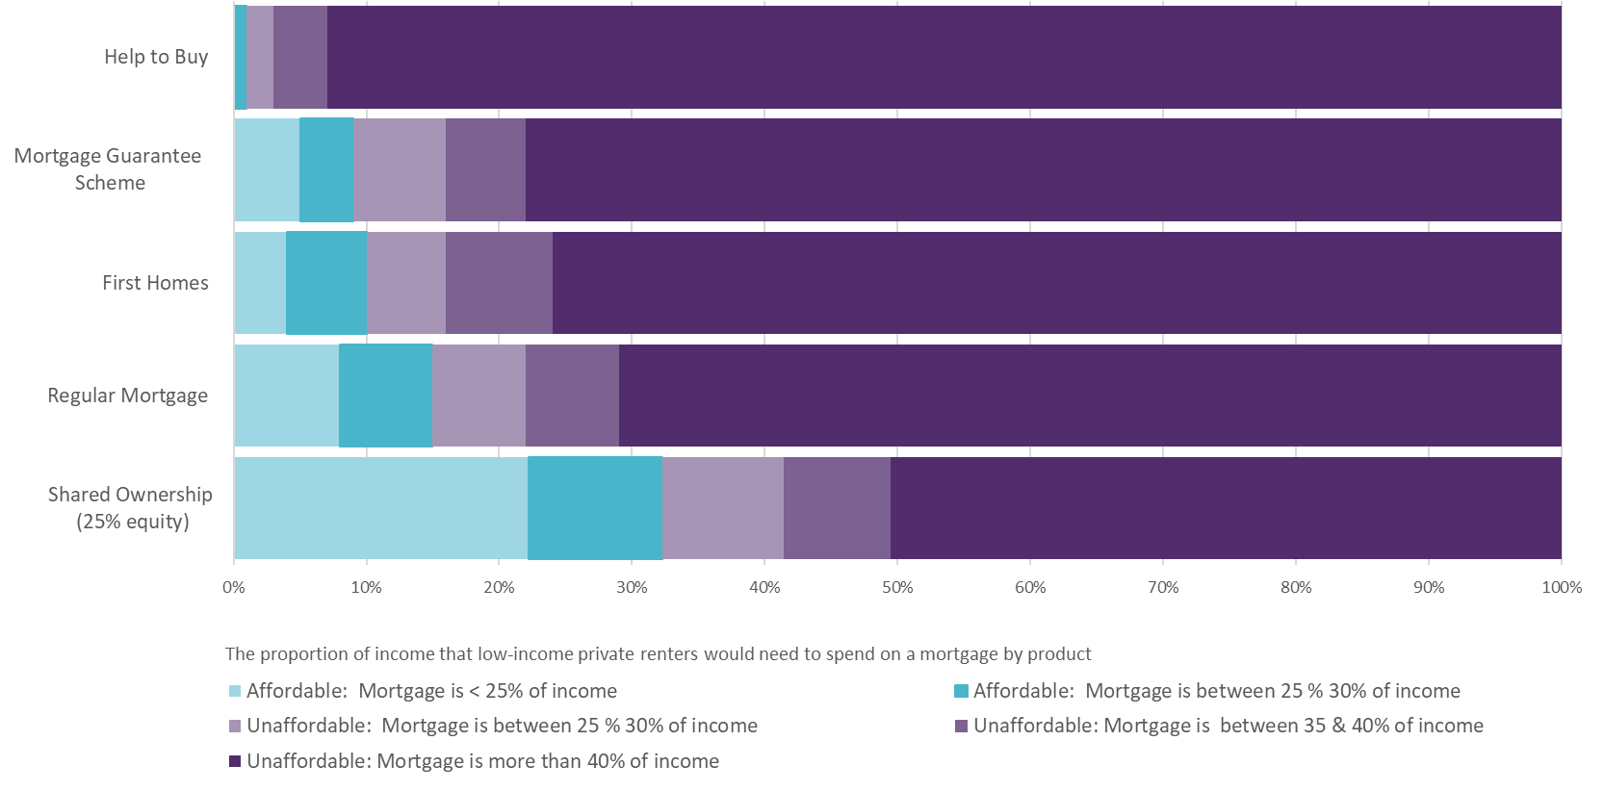
These figures are before deposit requirements are taken into consideration. As outlined above, more than six in ten private renting households have no savings, and with low-income private renting households on average only having £259 left after housing costs each week⁴, saving towards a deposit is a near impossible feat without extra support.

Renters on low incomes face a policy black hole; homeownership products are not the solution
These homeownership options are clearly not the right route to support low-income private renters into their own homes, with some of the options more expensive than a regular mortgage. This is because both Help to Buy and First Homes require new build homes to be purchased, which tend to be more expensive than existing homes in the market – the ‘new build premium’. The Mortgage Guarantee Scheme may benefit those struggling to save for a deposit, with only a 5% deposit needed, but requires a higher income to pay off a higher mortgage. As such, most of the schemes don’t make homeownership more accessible to those on low incomes.

Despite ministers repeatedly citing delivery of these homeownership schemes when defending the Government’s track record on helping struggling private renters, it is unlikely that these schemes were designed with low-income households in mind as the consumer. Instead, the Government’s failure to deliver enough new homes for social rent means that many low-income households are stuck in the private rented sector with no other options, unable to access Right to Buy – the one homeownership scheme that has been successful in helping low-income households onto the housing ladder.

Social rent is the most affordable rental product, and must be central in the Government’s plan for housing delivery

Social rent housing can provide more than half a million households currently paying rents they cannot afford with a genuinely affordable and secure home, and pull 600,000 people out of after housing costs poverty
Social rent dwellings are the most affordable rental product to provide many low-income private renters a route out of unaffordability. These are homes let by a local authority or housing association and are designed to provide housing that is affordable to people on low incomes, with rents typically set at around 50% to 60% of market rents.

JRF modelling has found that moving low-income private renting households in rental unaffordability into a social rent dwelling would lift over half a million households (552,000) and 1.6 million people out of unaffordability and reduce the pressures of paying high rents for the vast majority of the other half a million households. For these households, moving into a social rent dwelling would leave them on average £50 a week better off, increasing their household budget by 20%, putting money back into their pockets to spend elsewhere, and reducing the number of trade-offs required on other essential services and goods for their household. Even for those not lifted out of rental unaffordability, by our definition, social rent dwellings would reduce the depth of unaffordability they are in and go some way to alleviating the financial pressures they are under.

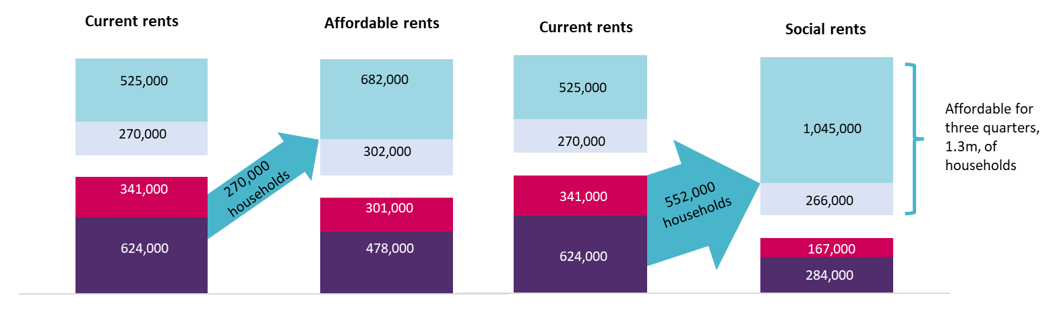
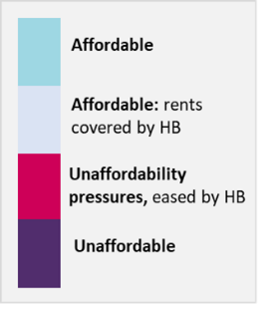
Graph 5: Social rents are the most affordable tenure which would be more affordable for most low-income private renting households and would move more than half a million (552,000) households into affordability
Affordability of ‘affordable rents’
Affordability of social rents
Source: JRF modelling of the impact of moving low-income private renting households to an appropriately sized affordable or social rent home at the average price for that dwelling by region and bedroom size. Direction arrows show gross movement into affordability; for a small number of households, moving from private to affordable or social rent will move them into unaffordability pressures or unaffordable rents.
Analysis uses Family Resources Survey 2019/20 and IPPR Tax and Benefit model. Incomes and prices at April 2021. Assumptions detailed in methodology note.
Social rent can also help provide a route out of poverty; we estimate that 600,000 people in after housing costs poverty in the private rented sector would be lifted out of poverty⁵ if they moved to a social rent dwelling. Social rent can unlock these 200,000 households from poverty, return more disposable income to them, and provide them with the stability of a long-term tenancy and the security of the better protections of the social rented sector.

As well as being more affordable for renters, the Housing Benefit currently paid by Government towards social rent homes is on average £1,664 a year less than for private rent homes (DLUHC, 2020). Based on our modelling, we estimate that moving the 552,000 households facing private rented unaffordability to the social rented sector would reduce the Housing Benefit bill by up to £1 billion a year, delivering better value for money for the taxpayer, on top of providing more affordable, better quality and more secure accommodation for low-income renters. Our previous analysis has also shown that over the long-term, significant savings to Housing Benefit help to offset the upfront investment in social rent (Earwaker and Baxter, 2020). Investment in social rent means money that would otherwise be spent on Housing Benefit, disappearing into the pockets of private landlords, is spent on assets, providing an essential service for struggling renters.

The insecurity and unaffordability of the private rental sector means it is not a suitable tenure to house and support those in temporary accommodation, or rough sleeping. While this report primarily focusses on the affordability challenges for renters, there are other compelling reasons why more homes for social rent are needed. For example, to provide homes for households with specific needs related to disabilities, ageing households for whom the private rented sector (PRS) is inadequate in retirement with lower incomes and changing health needs.

By rebalancing the tenure mix in its plan to build 300,000 new homes a year, the Government can deliver the housing we need to make renting more affordable for people on low incomes
While the Government’s new plan for social rent is a welcome improvement, it does not come close to meeting demand

The Government recently confirmed the details behind its plan for the Affordable Homes Programme until 2026 (DLUHC, 2021a). It has said it will deliver 119,000 homes over five years, an average of 24,000 a year. Broken down, this includes almost 6,000 homes for social rent a year, 11,400 for homeownership and 5,230 for affordable rent. And while the Government has said this is the largest single investment in a decade (DLUHC, 2021a), and it includes welcome additional support for social rent homes, it won’t be enough to deliver a house building programme on the scale, or including enough of the types, of the homes we need. We need 90,000 social rented homes a year to house 1.1 million households on social housing waiting lists (Bramley, 2018; DLUHC, 2021c) and the huge number of low-income households paying unaffordable private rents, many of whom will be on these waiting lists.

As Graph 6 shows, delivery of social rent homes through Government funding in the last five years has plummeted to an average of 566 homes a year. This compares with an average of more than 22,000 a year in the 15 years before that. So while the new targets of an average of 6,000 a year over the next five years are welcome, they are not enough to meet the scale of the problem.

Graph 6: The Government’s plan for social rent in 2021–26 is a welcome improvement on the last five years but is much smaller than the majority of the last 20 years
Source: Table 1000C in DLUHC, 2021b.
Note: The ‘proposed social rent delivery under the AHP’ is the yearly average of the 30,000 announced for social rent over the next five years (DLUHC 2021a).

Nearly a million low-income households are paying private rents they cannot afford, which means we need our affordable housing plans to be ambitious and scaled up to meet their needs. The solutions currently offered by the Government aren’t sufficient to address this problem. Looking ahead, there are two significant problems with the Government’s new plan:
1) 24,000 homes a year does not meet the scale of need for affordable homes in England. Independent analysis (Bramley, 2018) shows we need 145,000 new social homes across a variety of tenures delivered every year to meet demand, including 90,000 for social rent and 55,000 for affordable rent and homeownership. This doesn’t even cover a fifth of that need.
2) An average of 6,000 homes for social rent a year is an improvement on current delivery, but still clearly inadequate when we need 90,000 a year to meet demand, a significant proportion of which must be delivered through grant funding.
Even when combined with other sources of delivery, including via developers’ Section 106 contributions through the planning system – which currently account for more than half of our social rent homes a year – our analysis shows that we are still a long way off effectively tackling our housing crisis.

Graph 7 highlights how we need to both boost the scale of ambition in our affordable homes programme, as well as increase the proportion of homes delivered for social rent. Looking across all funding sources (grant funding through the AHP, Section 106 contributions, Right to Buy receipts etc), the Government is on track to only deliver around 9,000 social rented homes next year – and while the graph shows this is an improvement on 2019/20, it is a very small victory that only inches us towards the 90,000 we need a year. The 9,000 will also likely be dwarfed by Right to Buy sales, demolitions and conversions, continuing the trend of a net loss of social rent homes. The last five years has seen an average loss of almost 10,000 homes a year through Right to Buy alone, exceeding the amount of new social rent homes we can expect next year.

Graph 7: How the tenure balance of our new homes needs to change
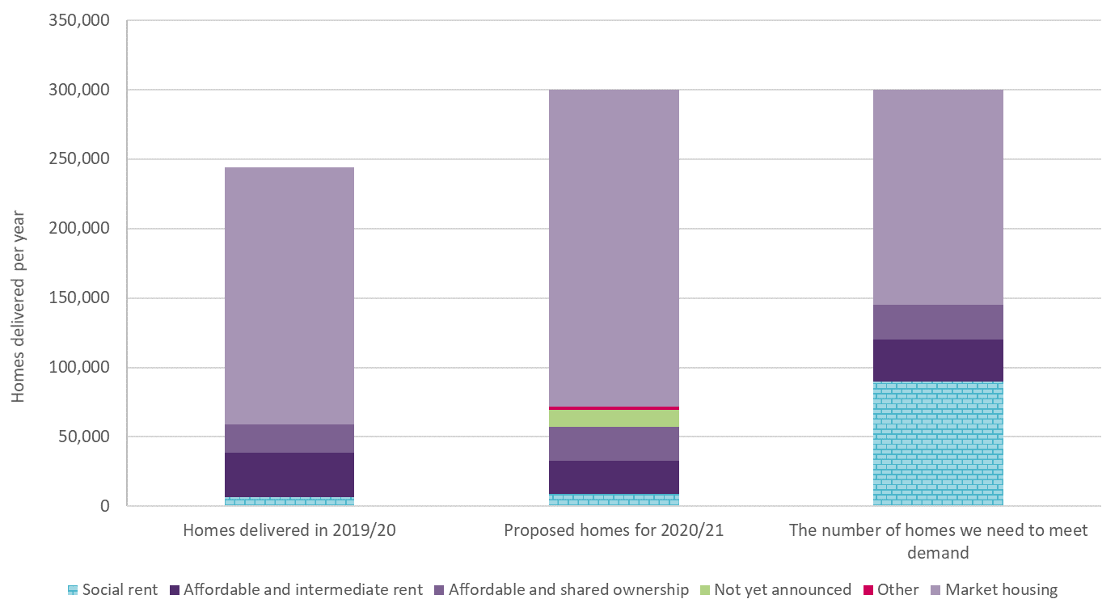
Source: Table 1012 in sheet 3 www.gov.uk/government/statistical-data-sets/live-tables-on-affordable-housing-supply (DLUHC,2021b) and Bramley (2018)
Note that the planned social houses (social rent, affordable and intermediate rent, affordable and shared ownership) for 2020/21 are a combination of the Affordable Homes Programme plans and the building starts from 2019/20 funded from non-AHP streams.

The dark purple bars show that the government’s commitment to ‘affordable rent’ and homeownership products have meant that these tenures are almost being delivered in sufficient quantities to meet existing need for these tenures. It is right to continue to deliver these, but it also needs to increase the amount of investment into social rent and reduce the proportion of the 300,000 homes being delivered through the market. This is what will close the policy black hole help and struggling renters, not more expensive market housing.

The Government can make renting more affordable by ensuring that 30% of the 300,000 new homes it has committed to deliver each year are for social rent
The most effective way of making renting affordable for low-income households to is build more homes for social rent. Our modelling shows that 552,000 households currently living in the PRS would be freed from unaffordable rents and provided with a secure, energy-efficient and quality home if they were moved to a social rent dwelling, and 200,000 private renting households would be lifted out of AHC poverty. There would also be substantial benefits for those facing homelessness, in temporary accommodation, and those social tenants who are in overcrowded or otherwise inappropriate homes. But this can only happen if the supply of new homes for social rent is substantially increased.

Building 90,000 homes for social rent a year will require a significant increase in funding for the Government’s Affordable Homes Programme, as one of the key levers for delivering social rented homes. The 2021– 26 Affordable Homes Programme has been allocated £12.2 billion over five years. We estimate that delivering the 90,000 social rent homes a year we need would require a capital investment of between an additional £11 and 14 billion a year. The precise cost will depend on whether the planning system can ensure that more homes for social rent are delivered through developer contributions (Section 106 or the proposed Infrastructure Levy). For example, the £11 billion scenario assumes that 80% of the 90,000 homes (72,000) are delivered through the AHP and the other 20% (18,000) is delivered via the developer contributions. This would share the cost across the private sector and government for delivering the affordable homes we need and is in line with the number of homes below market rent delivered through developer contributions in 2019/20. The £14 billion scenario assumes all 90,000 are delivered through the AHP. Any potential changes to the planning system (which remain uncertain at the time of writing) must deliver at least as many, and ideally more homes for social rent than the current system. Currently, developers’ Section 106 commitments fund 57% of all new homes for social rent (admittedly at the current low rates of delivery), and we cannot afford to lose any social rent supply.

In both scenarios, this is clearly a substantial increase in capital spending, but it is the most effective, credible and sustainable route to tackling the housing affordability crisis that is damaging the living standards of so many families across the country. While borrowing costs remain historically low for the Government (House of Commons, 2021), and we have the opportunity to build back better and tackle issues that won’t be going away anytime soon, this is the time to invest.

We need to see a sustained commitment from the Government to reap the long-term rewards of investing in homes for social rent
In the near term, new investment in homes for social rent will benefit the 1.1 million households currently on the social housing waiting list (DLUHC, 2021c), which includes current social as well as private tenants living in overcrowded homes, people experiencing homelessness and those living in temporary accommodation. Building enough homes for social rent so that low-income households in the private rented sector can also benefit will require greater ambition and a long-term commitment from the Government.

Over the long-term, a guaranteed pipeline of homes for social rent would also increase access to the most successful affordable homeownership scheme available to low-income renters in England: Right to Buy. A failure to replenish stock lost through the scheme over the last 40 years has closed off this route to homeownership for many families now stuck in the private sector. By committing to an ongoing programme of building homes for social rent and replacing those sold through Right to Buy, the Government can deliver on its aim of turning generation rent into generation buy while also providing housing that is genuinely affordable for people on low incomes.

Ramping up the delivery of homes for social rent to 90,000 a year will take time, and it is unrealistic to expect the Government to reach this target in full in this Parliament. However, a commitment to social rent from the Government would send an important signal and ensure that the investment and infrastructure needed to begin and sustain an ambitious programme of building homes for social rent is in place. This would also help the Government meet its manifesto commitment to end rough sleeping by the end of this parliamentary term. Social homes are often the best type of housing for people who have experienced street homelessness because they provide stable, secure and affordable accommodation (St Mungo’s, 2020)

It is clear that the housing system is not working for families on low incomes and the Government’s solutions are not working either. The impact of Covid-19 has only made this more apparent. Our analysis shows that ‘affordable rent’ and ever more elaborate homeownership schemes are not the answer. What we need is sustained investment in homes for social rent, which the Government should commit to at this autumn’s Comprehensive Spending Review.

Notes
- Those in the bottom 40% of equivalised before housing costs incomes.
- The bottom 40% of equivalised, before housing cost incomes.
- This briefing uses the acronym ‘BAME’ to refer to Black, Asian and minority ethnic communities when discussed as a collective. The authors recognise the limitations of the term and the concerns anti-racist organisations have raised over its use. JRF is currently engaged in a review on whether to use the term going forward.
- Average equivalised after housing costs income.
- This means that their new after housing costs income would be above the current after housing costs poverty line for 2021/22.

References
Barry, A (2021) We must loosen poverty’s grip on Black, Asian and ethnic minority people [Online]. York: Joseph Rowntree Foundation. Available at: www.jrf.org.uk/blog/we-must-loosen-povertys-grip-black-asian-and-ethnic-minority-people [accessed 1 September 2021].

Bramley, G (2018) Housing supply requirements across Great Britain: for low-income households and homeless people. London: Crisis and National Housing Federation. Available at: www.crisis.org.uk/ending-homelessness/homelessness-knowledge-hub/housing-models-and-access/housing-supply-requirements-across-great-britain-2018/ [accessed 1 September 2021].

Earwaker, R and Baxter, D (2020) Briefing: Build, build, build social housing: to stimulate our economy and unlock poverty from poverty and homelessness [Online]. York: Joseph Rowntree Foundation. Available at: www.jrf.org.uk/report/build-build-build-social-housing [accessed 1 September 2021].

House of Commons (2021) Briefing paper: Government borrowing, debt and debt interest: historical statistics and forecasts [Online]. London: House of Commons Available at: https://researchbriefings.files.parliament.uk/documents/SN05745/SN05745.pdf [accessed 1 September 2021]

Leslie, J and Shah, K (2021) (Wealth) gap year: the impact of the coronavirus crisis on UK household wealth. London: Resolution Foundation. Available at: www.resolutionfoundation.org/app/uploads/2021/07/Wealth-gap-year.pdf [accessed 1 September 2021]

Department for Levelling Up, Housing and Communities (2020) English Housing Survey 2019 to 2020@ headline report. London: DLUHC. Available at: www.gov.uk/government/statistics/english-housing-survey-2019-to-2020-headline-report [accessed 1 September 2021]

Department for Levelling Up, Housing and Communities (2021a) Press release: £8.6 billion for affordable homes to give boost onto housing ladder. London: DLUHC. Available at: www.gov.uk/government/news/86-billion-for-affordable-homes-to-give-boost-onto-housing-ladder [accessed 1 September 2021]

Department for Levelling Up, Housing and Communities (2021b) Affordable housing supply statistics (AHC) live table 1000: additional affordable homes provided by type of scheme, England. London: DLUHC. Available at: www.gov.uk/government/statistical-data-sets/live-tables-on-affordable-housing-supply [accessed 1September 2021]

Department for Levelling Up, Housing and Communities (2021c) Live table 600: numbers of households on local authorities’ housing waiting lists, by district, England, from 1997. London: DLUHC. Available at: www.gov.uk/government/statistical-data-sets/live-tables-on-rents-lettings-and-tenancies [accessed 1 September 2021]

Department for Levelling Up, Housing and Communities (2021d) Own your home: all schemes. London: DLUHC. Available at: www.ownyourhome.gov.uk/all-schemes/ [accessed 01 September 2021]

Office for National Statistics [ONS] (2021) Private rental market summary statistics in England, table 1.7. London: ONS. Available at: https://www.ons.gov.uk/peoplepopulationandcommunity/housing/datasets/privaterentalmarketsummarystatisticsinengland [accessed 01 September 2021]

St Mungos (2020) Homes for good: The role of social housing in ending rough sleeping – full report. London: St Mungos. Available at: www.mungos.org/publication/home-for-good-the-role-of-social-housing-in-ending-rough-sleeping/ [accessed 01 September 2021]

